**Effective Natural Treatments for Cold Sores: Say Goodbye to Painful Blisters**

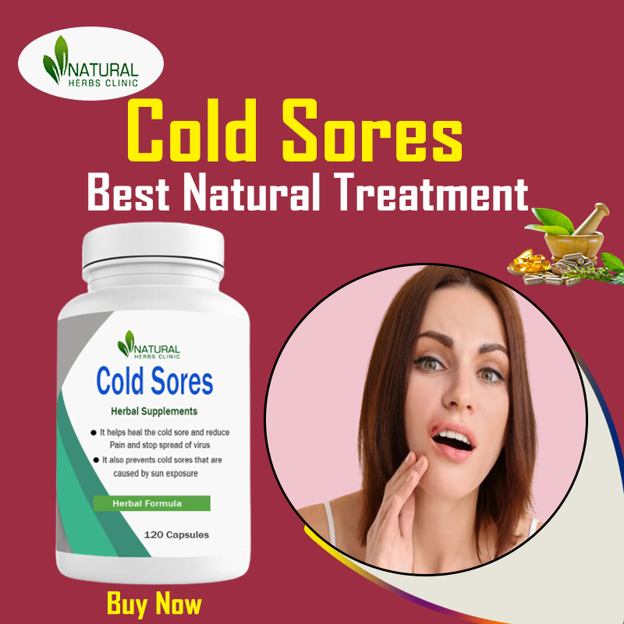

**Obtain** [**effective Natural Treatments for Cold Sores**](https://naturalherbsclinic.bloggersdelight.dk/2023/07/22/effective-natural-treatments-for-cold-sores-say-goodbye-to-painful-blisters/) **to relieve pain, promote healing, and prevent future outbreaks. Say goodbye to painful blisters with these remedies.**