Metaverse in Health Care - Explore the Opportunities, Use Cases and Benefits

The emergence of the metaverse is driving a significant revolution in the healthcare industry. This transformation is particularly evident in fields like medical and surgical imaging, mental health, and medical training.

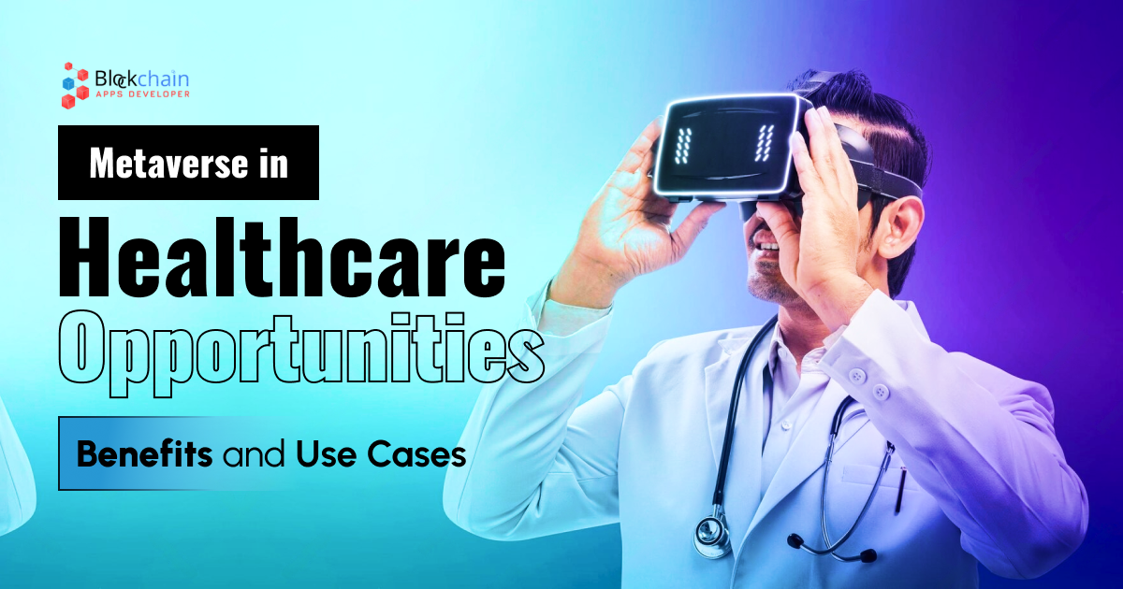

Metaverse in Health Care - Opportunities and Advancements

The healthcare industry is on the cusp of a transformative era, and the metaverse is at the forefront. This immersive digital landscape is not just for gaming and entertainment; it's rapidly evolving into a powerful platform for healthcare research, development, and patient care.

Here are some opportunities for metaverse in healthcare industry:

Telehealth

The boundaries between physical and virtual are blurring, and healthcare is at the forefront of this revolution. Telehealth has blossomed into a powerful tool, merging seamlessly with the immersive world of the metaverse.

Step into a virtual doctor's office, complete with examination rooms, waiting areas, and even interactive displays. Patients in remote areas or with limited mobility can now access top-notch healthcare without leaving their homes. The metaverse removes geographical barriers, making specialist consultations a reality for everyone.

DigitalTwin

The power of digital twins, virtual replicas of real-world systems or processes built using data to understand and predict their behavior. These digital simulations let you experiment and analyze without the risks or limitations of the real world. As technology advances and data becomes more readily available, these virtual test dummies will play an increasingly important role in shaping our future, from healthcare to countless other industries.

Surgical Procedure with AR

The future of healthcare is peeking through the lens of augmented reality (AR). This innovative technology is transforming the way we diagnose, learn, and practice surgery, offering a glimpse into a more precise, efficient, and even optimistic vision of medical care.

The future of healthcare is bright, illuminated by the power of augmented reality. This technology is not just changing the way we practice medicine; it's changing the way we experience it, creating a more optimistic, personalized, and ultimately, healthier future for all.

Radiology Visualization

The metaverse is still in its nascent stages, but the potential benefits of immersive medical visualization are undeniable. As technology advances and becomes more accessible, we can expect to see even more transformative applications emerge.

Virtual reality simulations are used to diagnose neurological disorders by examining brain activity in a dynamic 3D environment.

AR-powered physical therapy sessions where patients receive real-time feedback on their movements, optimizing their rehabilitation outcomes.

Personalized virtual worlds offer interactive health education, empowering patients to manage chronic conditions and make informed decisions about their well-being.

Virtual Hospital

The virtual hospital is not just a digital replica of its physical counterpart; it's a bold leap forward, driven by the potent synergy of the metaverse and cutting-edge technologies. As these technologies mature and become more accessible, we can expect to see even more innovative applications emerge, transforming the way we deliver and receive healthcare, and making it more accessible, efficient, and personalized for everyone.

Geographic barriers crumble in the metaverse. Virtual hospitals can extend their services to remote communities and underserved areas, providing vital care to patients who might otherwise lack access. This isn't just a futuristic vision; it's a rapidly evolving reality offering a multitude of advantages that reshape healthcare as we know it.

Digital Therapeutic

Digital therapeutics unlocks a treasure of opportunities to improve accessibility, personalize treatment, and revolutionize the way we approach mental and physical health. These software-based interventions, delivered through mobile apps, VR/AR platforms, and other digital tools, are soaring toward new heights in the immersive realm of the metaverse.

Benefits of Metaverse in the Healthcare Industry

Enhanced Accessibility
Improved Patient Engagement
Advanced Treatment and Diagnostics
Transformative Research and Development

Metaverse in healthcare provides accessible and personalized care to patients around the world with virtual hospitals, doctors can easily monitor your health in real-time, proactively suggesting preventive measures. BlockchainAppsDeveloper helps you to get a glimpse into a healthier future where technology and healthcare converge to create a more accessible, personalized, and equitable healthcare system for all.

Process of Developing Metaverse Healthcare Platform

From project and document gathering to ensuring a successful launch, our developers' team will help you build a metaverse healthcare platform.

Project Requirement gathering
Design Requirements
Development of Metaverse Healthcare Platform
Quality Assurance and Testing
Maintenance and App Launching

Use-Cases of Metaverse Healthcare as the metaverse develops

Phase 1 - Current state

As metaverse technologies develop, these use cases are proving the best in key areas:

Surgical Procedures
Behavioral and Mental Health
Medical training
Pain Management and Physical Therapy
Testing and Diagnostics

Phase 2 - The next five years

Along with phase 1, new use cases will emerge as technologies advance:

Disability and Elder Care
XR-supported clinical trials
Hospital Digital twin
Claims Data
Provider Data

Phase 3 - The Future of Metaverse in Healthcare

Metaverse will become standard in healthcare, and new use cases will emerge along with Phase 1, and Phase 2:

Patient Data
XR robotic surgical procedures
XR/M-world Hospitals
Care Navigations

BlockchainApspDeveloper helps you to build your virtual worlds tailored to specific patient needs, allowing them to interact in 3D environments that feel natural and engaging, empowering your patients with personalized, immersive experiences that drive better outcomes.

Why choose BlockchainAppsDeveloper as your Metaverse Development Company?

Metaverse in Healthcare offers many advantages for businesses like individual care, experimental learning, remote healthcare services, etc. While potential security challenges remain, healthcare pioneers are already embracing the metaverse to deliver exceptional care.

To navigate this journey safely, starting on the right foot is crucial. That's where BlockchainAppsDeveloper - a top metaverse development company comes in. We build user-centric metaverse platforms tailored to your specific needs, empowering patients and healthcare professionals.

Don't wait to take advantage of the metaverse's potential to transform healthcare. Connect with our team of experts and let's create a platform that puts the power in your patients' hands, leading to healthier, happier lives.

Reach us:

WhatsApp - +919489606634

Email - support@blockchainappsdeveloper.com

Telegram - https://telegram.me/BlockN_Bitz

Meta Title

Metaverse in Healthcare - Opportunities, Benefits, and Use cases

Meta Description

BlockchainAppseveloper provides an ultimate guide for the metaverse in healthcare, its opportunities, benefits, and use cases to accelerate medical breakthroughs.

Meta Keywords

healthcare metaverse, metaverse in healthcare, metaverse healthcare, metaverse and healthcare, healthcare in the metaverse, medical metaverse, metaverse medicine, metaverse for healthcare, metaverse in medicine, metaverse healthcare platform, metaverse healthcare solutions

