# Premature Ejaculation Food Supplements: A Conclusive Guide



Learn about the benefits of taking natural premature ejaculation food supplements and find out how they improve sexual performance.

# Early Ejaculation Supplements: Unlocking the Power

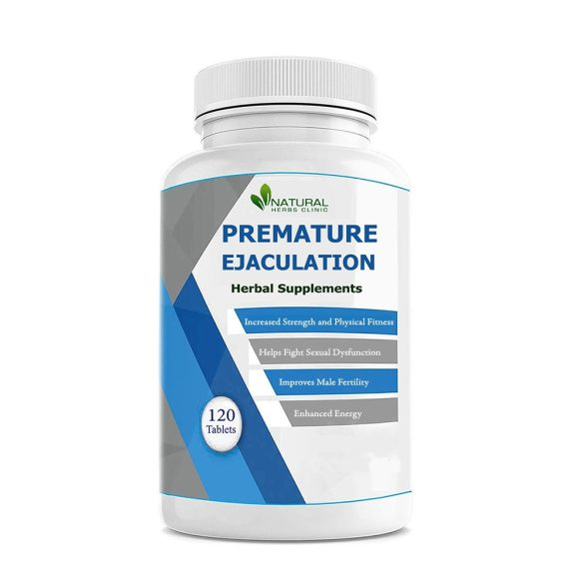

[Early ejaculation supplements](https://naturalcureremedies.hashnode.dev/early-ejaculation-supplements-unlocking-the-power) are dietary products formulated to help men extend their stamina and improve their performance in bed. These supplements often contain a variety of natural ingredients known for their potential benefits in addressing premature ejaculation.